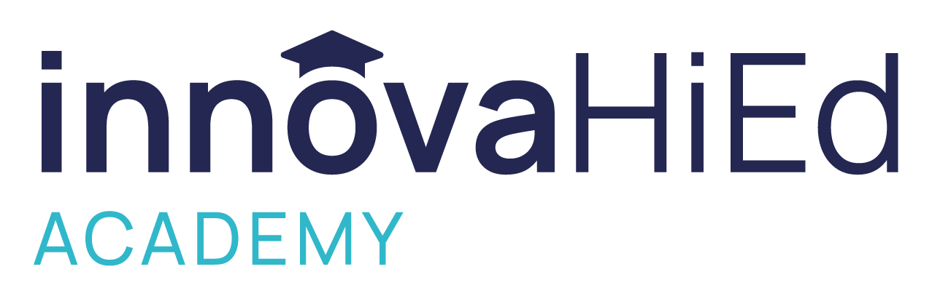
InnovaHiEd begins a new year with new offerings and services for the Engineering Education community all over the world. The 5th Cohort of the successful International Engineering Educator Certification Program (IEECP) accredited by IGIP is currently under development, with participants from Argentina, Chile, Colombia, Paraguay, Peru and Spain. A 6th Cohort organized in collaboration with IFEES and ICACIT has been announced; this cohort will begin in July this year.
We will actively participate in the 25th International Conference on Interactive Collaborative Learning (ICL 2022) offering a workshop about innovations in STEAM education.
InnovaHiEd has also announced the 2nd edition of the Lueny Morell Award to Educational Innovation in Higher Education in STEAM. This Award recognizes a relevant initiative of teaching innovation in the field of science, technology, engineering, arts, and mathematics (STEAM), characterized by its significant contribution and impact on Higher Education.
Finally, we are also offering professional consulting services for Higher Education institutions through a team of professionals with proven experience to improve academic and management processes.

