Subject: Siemens Supporting the Development of New Sustainability Toolkit

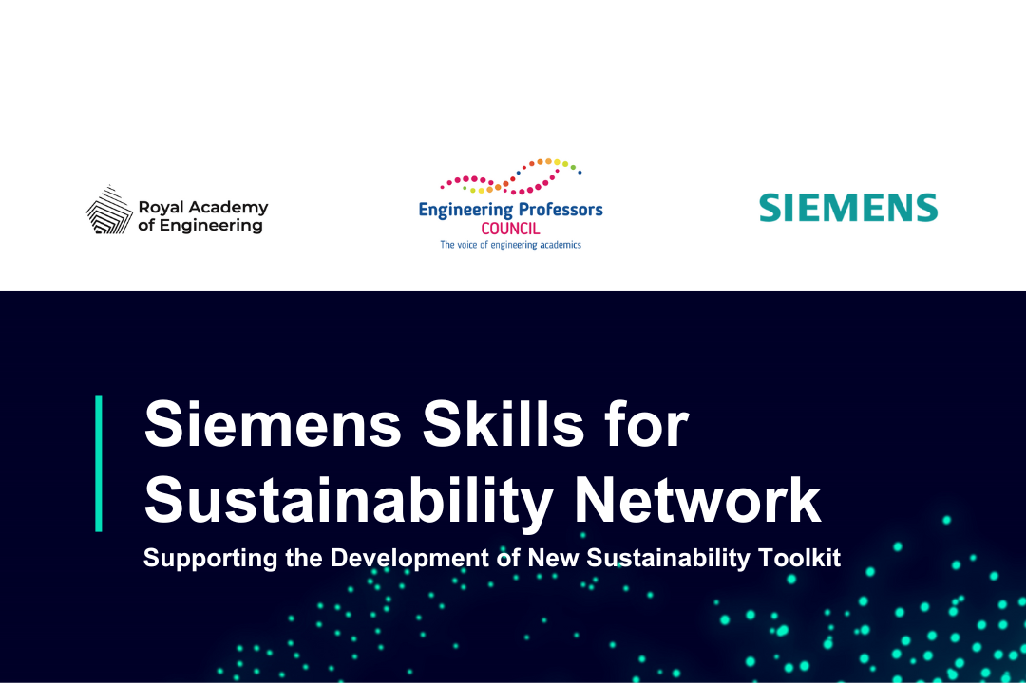

Dear Colleagues

We are pleased to share that our partners at Siemens are working with the UK’s Engineering Professors’ Council (EPC) and the Royal Academy of Engineering to devise a much-needed Sustainability Toolkit.

Due for launch next year, the Toolkit is currently in development phase and will deliver an essential global resource for engineering educators to ensure graduates are fully equipped to take on sustainability challenges.
Learn more in this article which features ideas and insights around four key tool areas shared during the first Siemens Skills for Sustainability Network global online gathering, including:
- Tools for Understanding, to provide educators the knowledge they need about sustainability issues and skills.
- Tools for Integrating, to help educators weave sustainability into existing curricula.
- Tools for Measurement and Assessment, so that educators can demonstrate relevance and impact.
- Tools for Collaboration, so we can learn from and support each other.
READ ARTICLE
Find out more about the sustainability toolkit and how you can contribute here!

The Siemens Skills for Sustainability Network is a valuable community of over 240 members, representing 170 institutions in 40 countries around the world. If you would like to become a member and gain access to the many useful reports, resources and case studies shared by members as well as by Siemens, along with the opportunity to get involved in future dialogues register here.

